Day 23 - 02nd Aug 2025

JUNIT testcases - atleast one or two if working pla raise your hands.
TASK 01

Tags Annotation:

import org.junit.jupiter.api.Test;
import org.junit.jupiter.api.Tags;
import org.junit.jupiter.api.Assertions.assertEquals;
class TestCase02 {
@Test
@Tags("firstPriority")
void testMethod01() {

}

@Test
@Tag("firstPriority")
void runTestcase02() {

}
@Tags("fastTag")
void testMethod03() {

}

@Test
@Tag("slowTag")
void runTestcase04() {

}
}

package lib;

import org.junit.jupiter.api.Test;
import org.junit.jupiter.api.Tag;

import static org.junit.jupiter.api.Assertions.assertEquals;

class TestCase02 {

@Test
@Tag("firstPriority")
void testMethod01() {
int expected = 2;
int actual = 1 + 1;
assertEquals(expected, actual);
}

@Test
@Tag("firstPriority")
void runTestcase02() {
String str = "JUnit";
assertEquals("JUnit", str);
}

@Test
@Tag("fastTag")
void testMethod03() {
assertEquals(4, 2 * 2);
}

@Test
@Tag("slowTag")
void runTestcase04() {
assertEquals(10, 5 + 5);
}
}
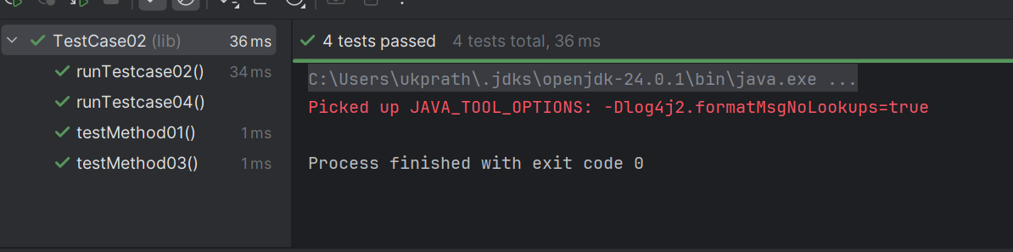

—----------------------------------------------------------------------------------------------------------------------
Design patters:
- Creational Design Patterns:
types of Creational design Patterns:
- Factory Method
- Singleton Method
- Abstract Factory Method
- Builder Method
- Prototype Method

Factory Method Design Pattern
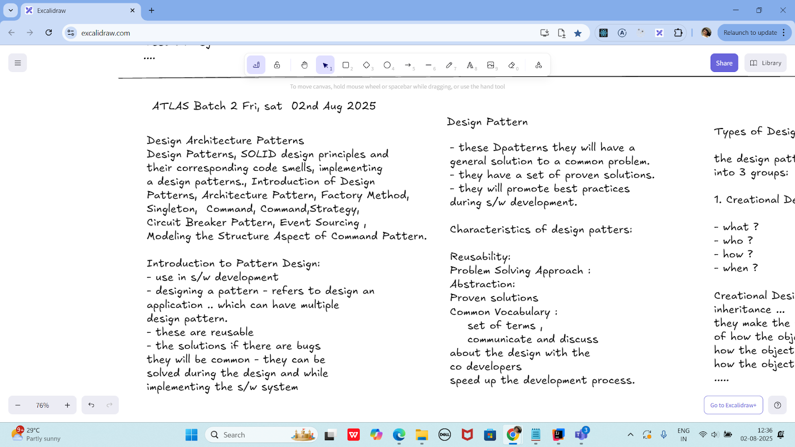

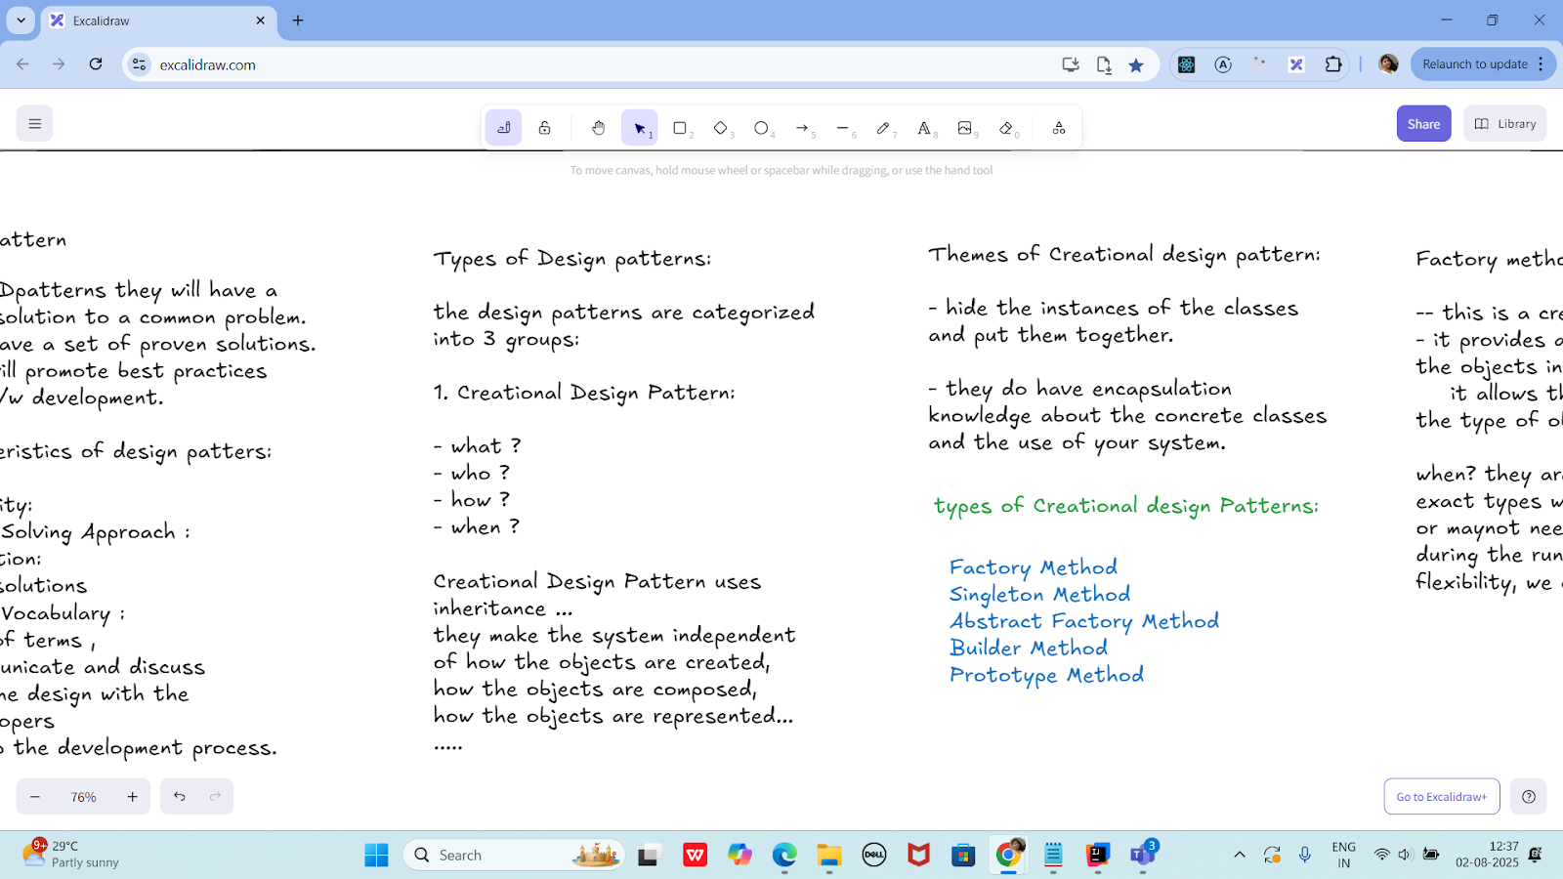

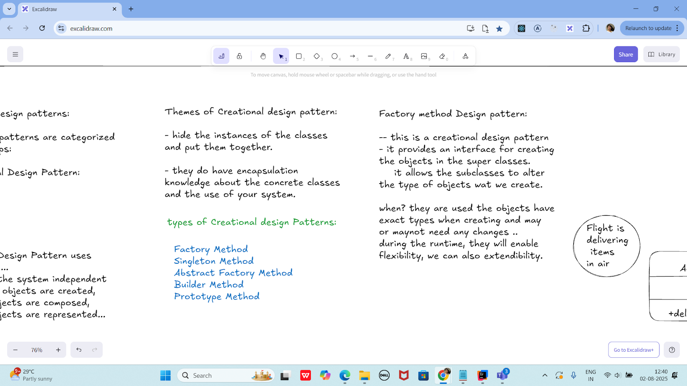

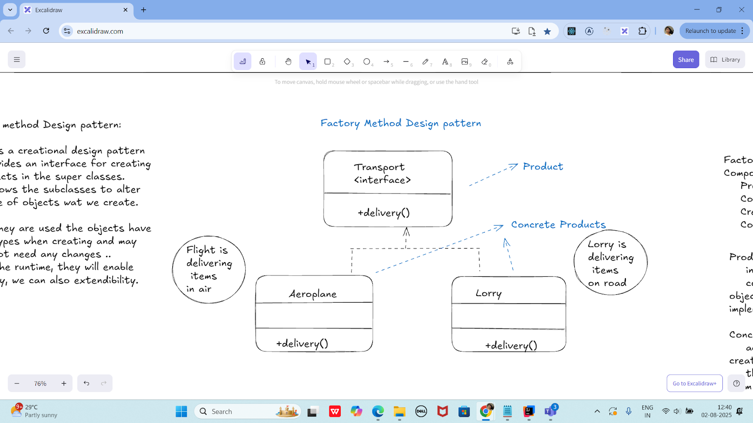

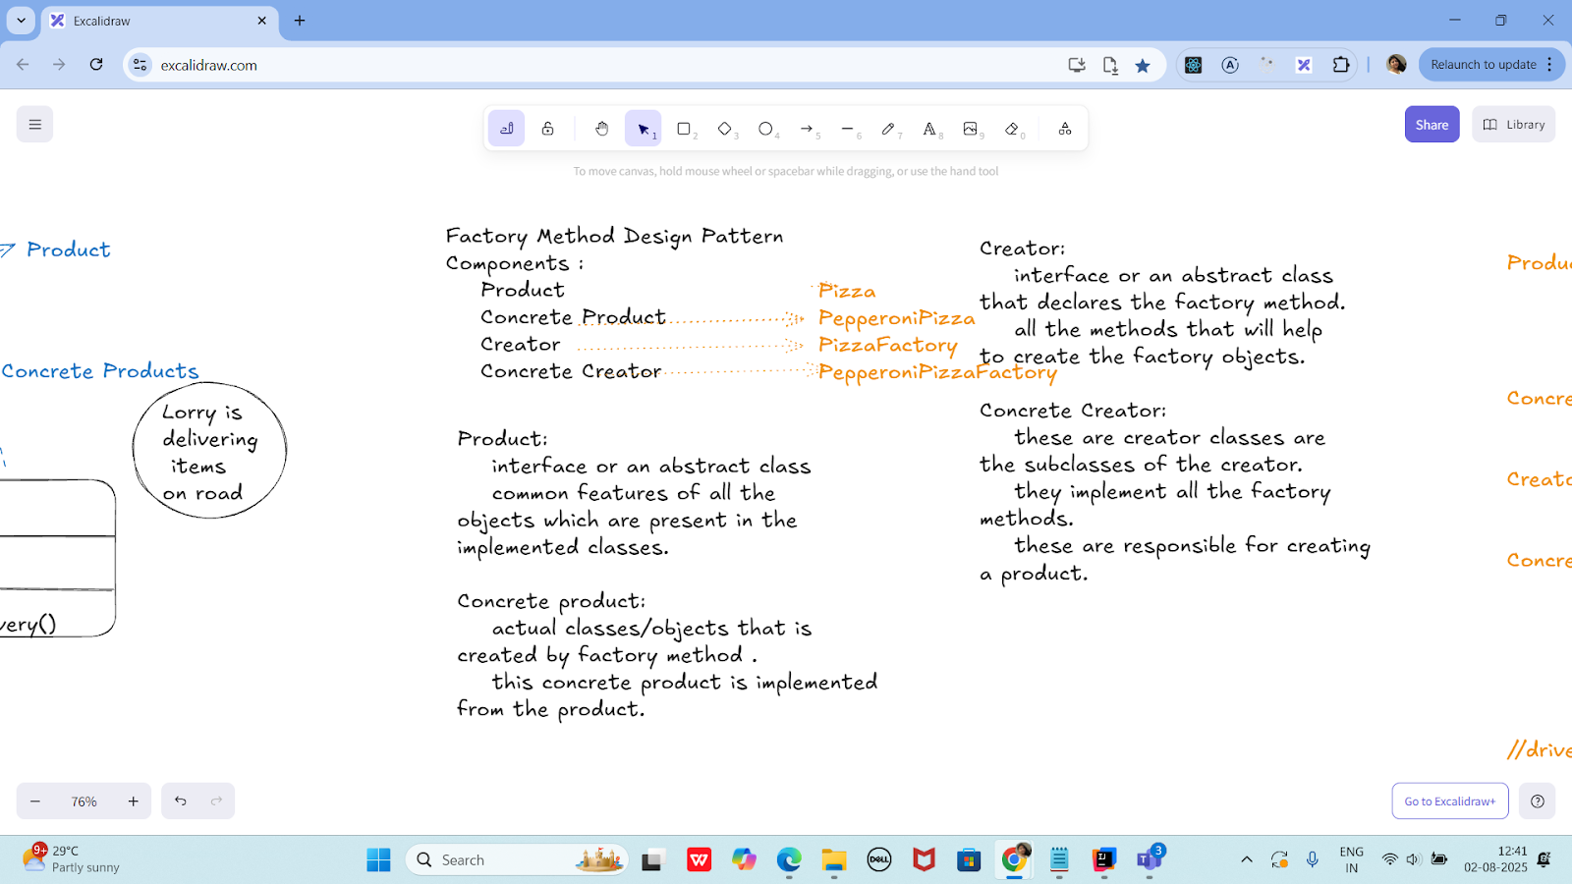

Product :-> Pizza interface/abstract class
preparation();
baking();
cutting();
boxing();
ConcreteProduct --> PepperoniPizza
//implement all the features of Pizza.

Creator ---> PizzaFactory interface/abstract class
Pizza createPizza(); - type is Pizza

Concretecreator ---> PepperoniPizzaFactory
@Override
Pizza createPizza() {
....
retrun new PepperoniPizza();
}

//driver class
class Sams {
psvm() {
PizzaFactory pfobj = new PepperoniPizzaFactory();
Pizza pobj = pfobj.createPizza();
}

}
public abstract class Pizza {
public abstract void preparation();
public abstract void baking();
public abstract void cutting();
public abstract void boxing();
}
public class PepperoniPizza extends Pizza {
@Override
public void preparation() {
System.out.println("Preparing pepperoni toppings and dough.");
}

@Override
public void baking() {
System.out.println("Baking pepperoni pizza at 350 degrees.");
}

@Override
public void cutting() {
System.out.println("Cutting pepperoni pizza into slices.");
}

@Override
public void boxing() {
System.out.println("Boxing pepperoni pizza in official box.");
}
}
public abstract class PizzaFactory {
public abstract Pizza createPizza();
}
public class PepperoniPizzaFactory extends PizzaFactory {
@Override
public Pizza createPizza() {
System.out.println("Creating a PepperoniPizza via factory...");
return new PepperoniPizza();
}
}
public class Sams {
public static void main(String[] args) {
PizzaFactory pfobj = new PepperoniPizzaFactory();
Pizza pobj = pfobj.createPizza();

pobj.preparation();
pobj.baking();
pobj.cutting();
pobj.boxing();
}
}

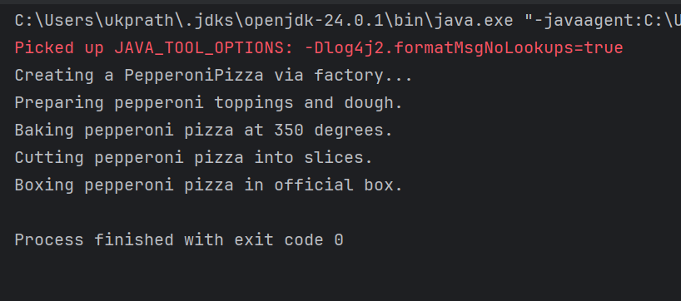

Singleton Method Design principle

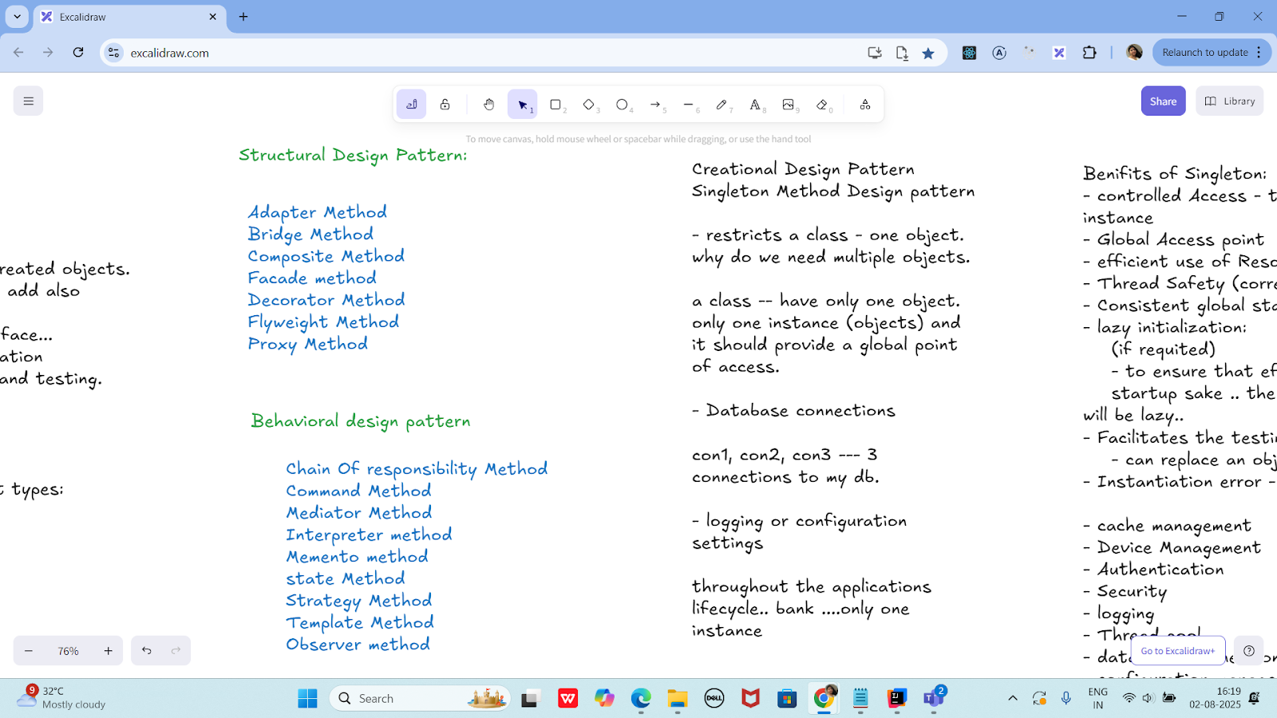

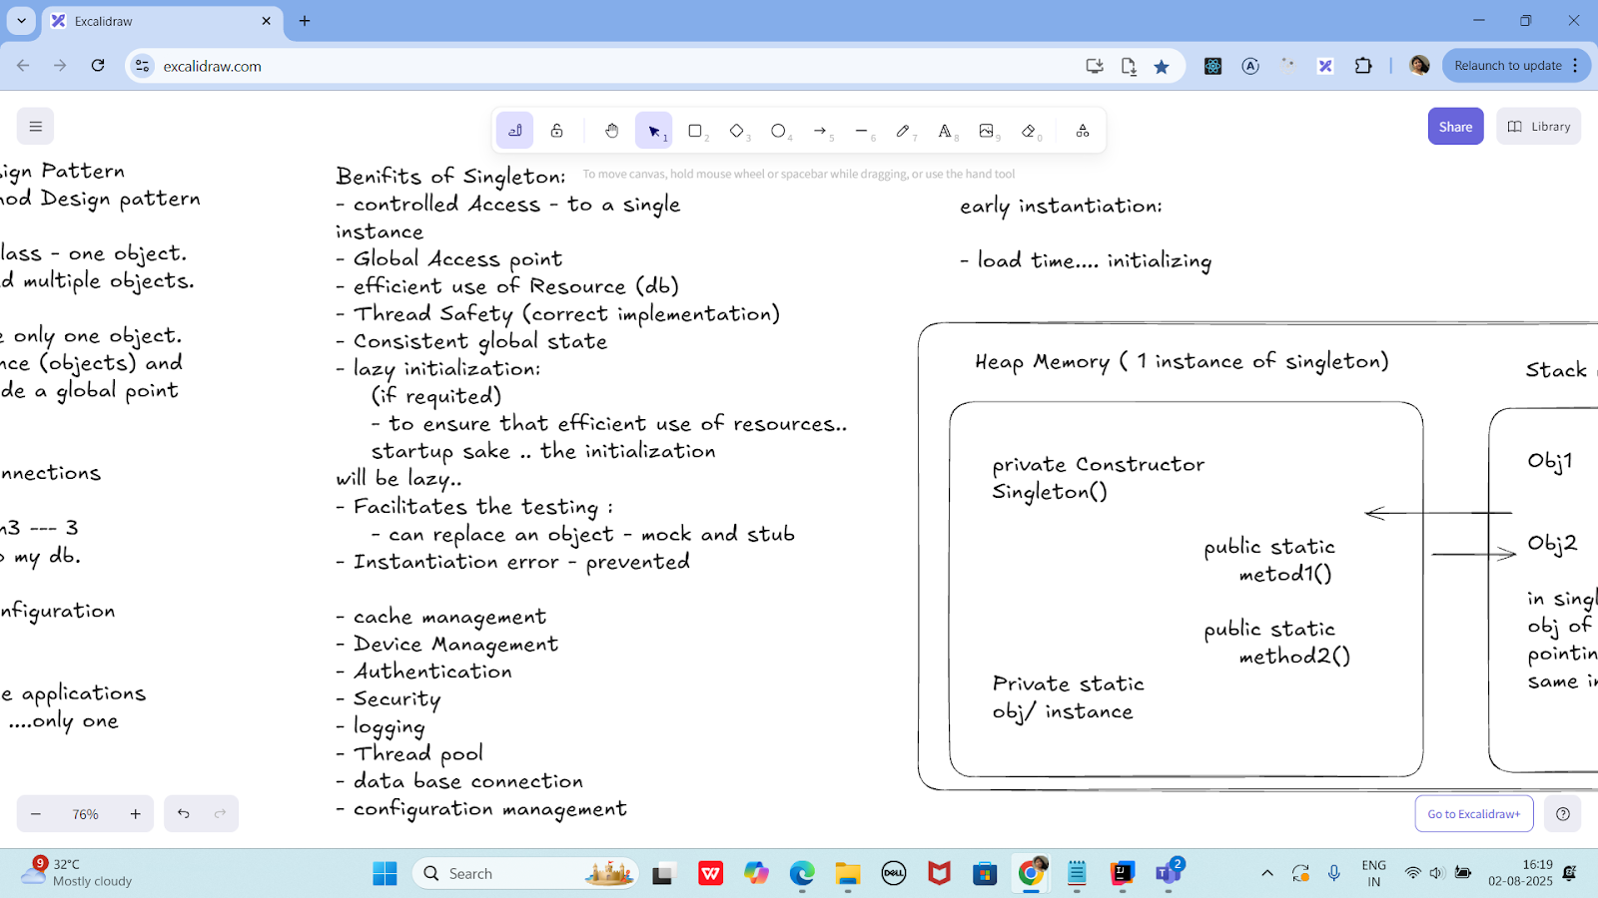

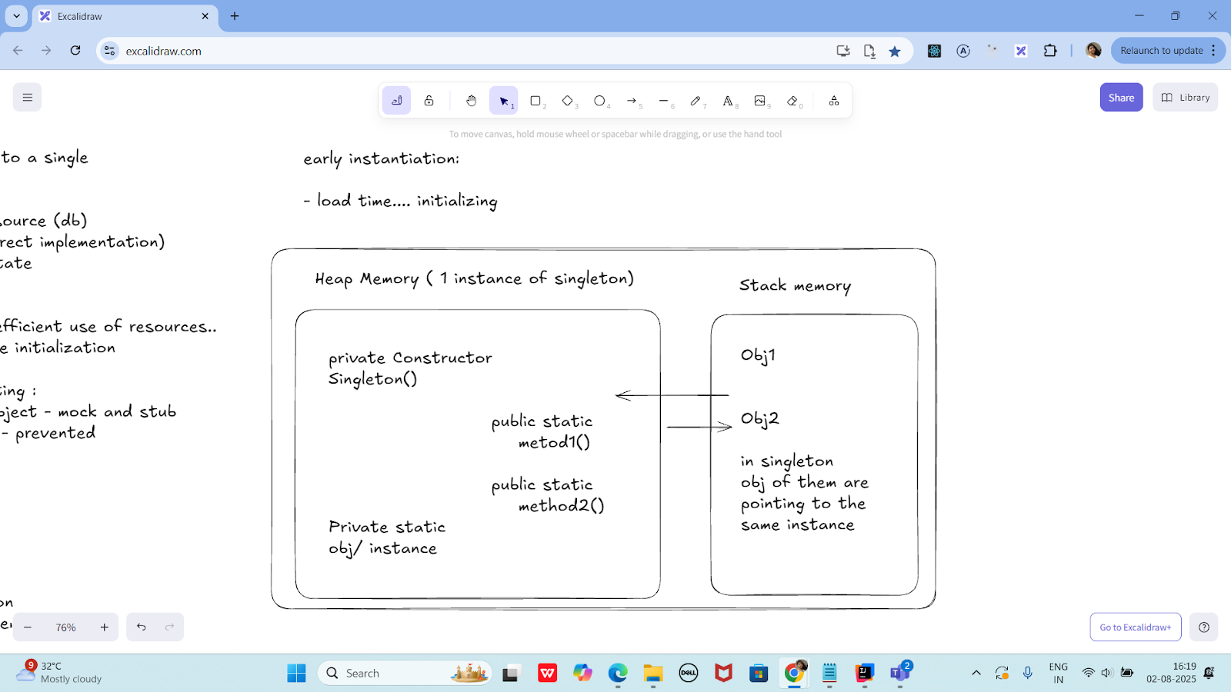

class SingletonDemo {
private static SingletonDemo instance; // lodinids.. //pass/ pin no
private SingletonDemo() {
System.out.println("initiating the singleton");
}
public static SingletonDemo getInstance() {
if (instance == null) {
instance = new SingletonDemo();
System.out.println("in get instance");
}
return instance;
}
public static void doHere() {
System.out.println("doing here some thing");
}
}

public class SingletonDP {
public static void main(String[] args) {
SingletonDemo.getInstance().doHere();
// SingletonDemo obj = new SingletonDemo();
// obj.doHere();
// SingletonDemo obj2 = new SingletonDemo();
// obj2.doHere();
}
}

—----------------------------------------------------------------------------------------------------------------------------------
—----------------------------------------------------------------------------------------------------------------------------------

Home Tasks:
Home Task 1:
Write a test case for the below java file

public class Junit4Test {
public int compare(int n1, int n2) {
if (n1 > n2) return 1;
return -1;
}
}
import org.junit.Test;
import static org.junit.Assert.assertEquals;

public class Junit4TestTest {

@Test
public void testCompare_WhenFirstIsGreater() {
Junit4Test obj = new Junit4Test();
int result = obj.compare(10, 5);
assertEquals(1, result);
}

@Test
public void testCompare_WhenSecondIsGreater() {
Junit4Test obj = new Junit4Test();
int result = obj.compare(3, 8);
assertEquals(-1, result);
}

@Test
public void testCompare_WhenEqual() {
Junit4Test obj = new Junit4Test();
int result = obj.compare(7, 7);
assertEquals(-1, result); // Because your logic returns -1 even if both are equal
}
}

Home task 2:
public int compare(int n1, int n2) {
if (n1 > n2) return 1;
else if (n1 < n2) return -1;
return 0;
}
public class CompareUtil {
public int compare(int n1, int n2) {
if (n1 > n2) return 1;
else if (n1 < n2) return -1;
return 0;
}
}
import org.junit.Test;
import static org.junit.Assert.assertEquals;

public class CompareUtilTest {

CompareUtil obj = new CompareUtil();

@Test
public void testCompare_FirstGreater() {
assertEquals(1, obj.compare(10, 5));
}

@Test
public void testCompare_SecondGreater() {
assertEquals(-1, obj.compare(4, 9));
}

@Test
public void testCompare_BothEqual() {
assertEquals(0, obj.compare(7, 7));
}
}
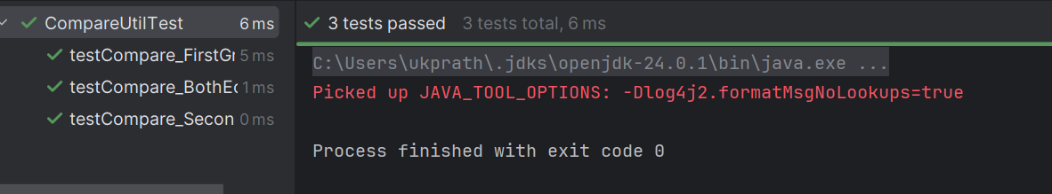

Hoe Task 3:

Include a test case and run the test suite.

Test Suite:

- its a bundle of unit test cases and run them
all together.
@Suite
@RunWith

TestSuite Demo

import org.junit.runner.RunWith;
import org.junit.runners.Suite;

@RunWith(Suite.class)

@Suite.SuiteClasses( {
JunitTest01.class,
JunitTest02.class,
JunitTest03.class
})

public class TestSuiteDemo {

}

JunitTest01.java

import org,junit.Test;
import static org.junit.Assert.assetEquals;
import org.junit.Igore;
public class junitTest01 {

String msg = "running test01 ";

MessageUtil msgUtilobj = new MessageUtil(msg);
//MessageUtil is a utility class
//store a message
@Test
public void msgTest() {
sout("we are inside the msgtest()");

assertEquals(msg, msgUtilobj.printMessage());
}
}

junitTest02.java

test Runner

public class MessageUtil {
private String message;

public MessageUtil(String message) {
this.message = message;
}

public String printMessage() {
return message;
}
}
import org.junit.Test;
import static org.junit.Assert.assertEquals;

public class JunitTest1 {

String msg = "running test01 ";
MessageUtil msgUtilobj = new MessageUtil(msg);

@Test
public void msgTest() {
System.out.println("Inside msgTest()");
assertEquals(msg, msgUtilobj.printMessage());
}
}
import org.junit.Test;
import static org.junit.Assert.assertEquals;

public class JunitTest2 {

String msg = "running test02 ";
MessageUtil msgUtilobj = new MessageUtil(msg);

@Test
public void msgTest() {
System.out.println("Inside JunitTest02 msgTest()");
assertEquals(msg, msgUtilobj.printMessage());
}
}
import org.junit.Test;
import static org.junit.Assert.assertEquals;

public class JunitTest3 {

String msg = "running test03 ";
MessageUtil msgUtilobj = new MessageUtil(msg);

@Test
public void msgTest() {
System.out.println("Inside JunitTest03 msgTest()");
assertEquals(msg, msgUtilobj.printMessage());
}
}
import org.junit.runner.RunWith;
import org.junit.runners.Suite;

@RunWith(Suite.class)
@Suite.SuiteClasses({
JunitTest1.class,
JunitTest2.class,
JunitTest3.class
})
public class TestSuiteDemo {
// No code needed here — just grouping tests
}
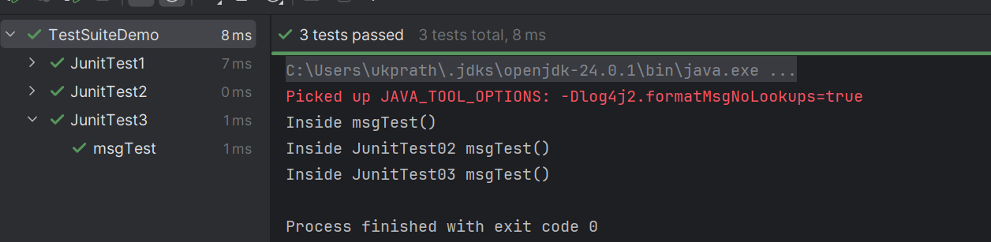
Home Task 4:

Implement the above code also add one more test case and test runner.. And execute the test suite.

================================================================================================================================================
Info Box
================================================================================================================================================

Info Box (Carry forward from Day 22 02nd Aug juz fyi..

Plz refer Best Programming Practices - Doc 08 in Docs to study

Updated link at 12.17 ..

https://excalidraw.com/#json=lKmZDbhZ5V6ZRlQ3zJOXv,K6r0FziLUTf3htjdUrnN4w

Updated link at 15.57

https://excalidraw.com/#json=Mp0F2MJiO57HKm74LVHXK,XmhQybYlqAswiHdRIeokDQ

Junit dependency

https://junit.org/junit4/dependency-info.html

<dependencies >
<dependency>
<groupId>junit</groupId>
<artifactId>junit</artifactId>
<version>4.13.2</version>
</dependency>
</dependencies >

The above dependency you need to add in the dependencies tag of pom.xml..

Junit Official link

Download
Hamcrest and Junit.jar file

https://junit.org/

Or add the below dependency
<dependency>
<groupId>org.junit.jupiter</groupId>
<artifactId>junit-jupiter-api</artifactId>
<version>6.0.0-M2</version>
</dependency>

Hamcrest dependency

<!-- https://mvnrepository.com/artifact/org.hamcrest/hamcrest-junit -->
<dependency>
<groupId>org.hamcrest</groupId>
<artifactId>hamcrest-junit</artifactId>
<version>2.0.0.0</version>
<scope>test</scope>
</dependency>

JUNIT Jupiter api - junit.jar file link

https://mvnrepository.com/artifact/org.junit.jupiter/junit-jupiter-api

Junit Hancrest

https://mvnrepository.com/artifact/org.hamcrest/hamcrest

Exclidraw - updated link at 12.33..

https://excalidraw.com/#jso=cY4X2JOrLIvswxiToAxLB,01GKPhOFi8r3tEbo8hLCbw

Excalidraw - updated link at 16.20

https://excalidraw.com/#json=udpoNQTqmw4D3clX_tr_9,w7du3hqQcDaDyG7PGsZtzw

Codes for reference link → for uml codes
https://drive.google.com/drive/folders/1LwhNov1s1-vHzF9GPAObLSnP9kAvipmw?usp=sharing

Plz go through uml diagrams in page nos:
Docs 04 OOAD UML in doc to study

8 to 16
12
18 to 39
57 to 58
97
118
123
136
154 to 160

Plantuml site juz found .. plz check for reference

https://plantuml.com/use-case-diagram

================================================================================================================================================

